Albert Einstein and Robert Oppenheimer on Extraterrestrials

Albert Einstein and J. Robert Oppenheimer together wrote a TOP SECRET six-page document in June of 1947 entitled “Relationships with Inhabitants of Celestial Bodies”. It said the presence of unidentified spacecraft was accepted as de facto by the military. It also dealt with the subjects that you would expect competent scientists to deal with - i.e., where did they come from, what did the law say about it, what should we do in the event of colonization and/or integration of peoples, and why are they here?

Finally, the document addressed the presence of celestial astroplanes in our atmosphere as a result of actions of military experiments with fission and fusion devices of warfare.

It also appeared that our governments were not exactly forthcoming when it came to offering information about their own research on the matter. We only needed to look at the CIA’s announcement in August 2013 that Area 51 did not exist, despite decades of denying it and brandishing anyone who dared to suggest it as a mere conspiracy theorist. Fortunately, there did exist some scientifically-driven organizations, such as SETI and MUFON, which took an objective approach to the study of UFOs.

This brings us to an unclassified Top-Secret document written by Robert Oppenheimer, an American theoretical physicist, and Albert Einstein, a German theoretical physicist, who wrote a joint report on the issue of “Relationship with Inhabitants of Celestial Bodies”.

[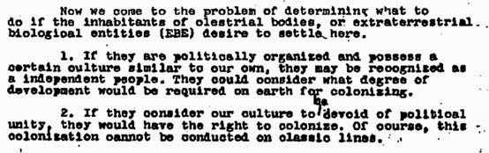](http://1.bp.blogspot.com/-LIHUukYfKeQ/U4XlPG-ndxI/AAAAAAAAaF0/3UKXXvOzJZc/s1600/Einstein+and+Oppenheimer+Paper+aliens.jpg)

The six-page document was the first document to use the phrase ‘Extra-terrestrial Biological Entities’ (EBEs). It said the presence of unidentified spacecraft was accepted as ‘de facto’ by the military – and this was dated June 1947.

The document dealt with issues such as: where extra-terrestrials may come from, what the law said about it, what we should do in the event of colonization and/or integration of peoples, and why they were here. The document suggested that in the event that EBE’s desire to settle here on earth there will be “profound change in traditional concepts” of law and the possible need for a new “Law Among Planetary Peoples.”

This document was important for two reasons. The first reason was that it addressed the possibility of life on other planets in a very logical and coherent way and explored what such a realization would mean. It also raised the question as to why if respected scientists such as Oppenheimer and Einstein were able to approach the subject in an academic way, “were we unable to engage in such sensible discussion today?”

The analysis presented by Oppenheimer and Einstein indicated that ‘disclosure’ of extra-terrestrial existence could cause irreversible damage to society, raising the possibility that our governments today may already know of extra-terrestrial existence but have considered the same issues raised by Oppenheimer and Einstein and ruled against disclosure.

If the population is told that intelligent extra-terrestrial beings not only exist but have been visiting our planets for thousands of years, being confronting with such evidence could cause upheaval in the domains of religion, society, law, and finance which, if not addressed properly, could bring chaos to the planet.

There are many questions to be answered. The document suggests that EBEs could be more intelligent and technologically advanced than us, and asks if this is the case, why would they come to Earth? Would it be to conquer and inhabit Earth, to peacefully cooperate with humans, or to study us in the same way that we study any new species that we encounter?  
*The document considers, if their civilization is more advanced than ours, how could a co-occupation of Earth be feasible?*

[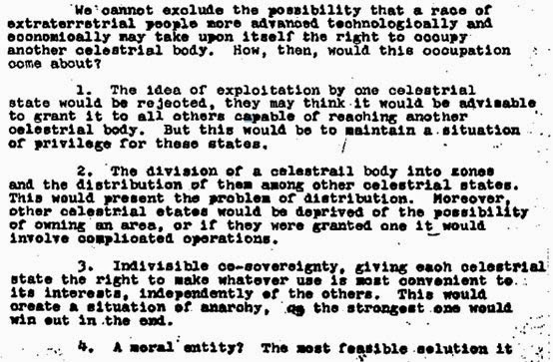](http://1.bp.blogspot.com/-z3c37wIxStE/U4XlkzX3uyI/AAAAAAAAaF8/1uXQKJh-d7Y/s1600/Einstein+and+Oppenheimer+paper+aliens1.jpg)

Imagine the situation in which advanced technology was given to our civilization – powerful defense systems, unlimited energy, cloaking devices, space travel to other solar systems, instant transportation devices, and so on. Now considering the current state of our civilization and the people that govern it, what would such a release of technology mean? One word: Chaos.

[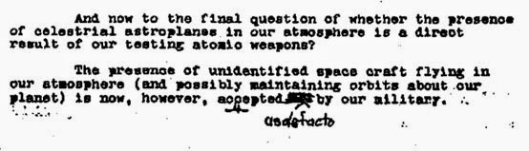](http://2.bp.blogspot.com/-OJfuz6MTZWw/U4XmPBmx6jI/AAAAAAAAaGI/XKX-cTtqg7A/s1600/einstein+and+oppenheimer+paper+aliens2.jpg)

It was not hard to understand that if UFOs were kept hidden from the public, it was for multiple reasons, which were logically addressed in this document. It was for these reasons, that we may never see a disclosure of extra-terrestrial existence in our lifetime.

In the meantime, it seemed that the most sensible approach was to keep an open-mind. It was usually the case that a debate raged between two opposite extremes – one side wanted to believe wholeheartedly that the cave art and mythological accounts were all descriptions of alien encounters, while the other side was so prepared to disbelieve that anything existed beyond the scope of their reason that they will ignore even the most blatant rendition. If scientists could overcome the ridicule and disparaging remarks that come with exploring the subject matter, perhaps one day we will find irrefutable evidence that UFOs and extra-terrestrials did exist.